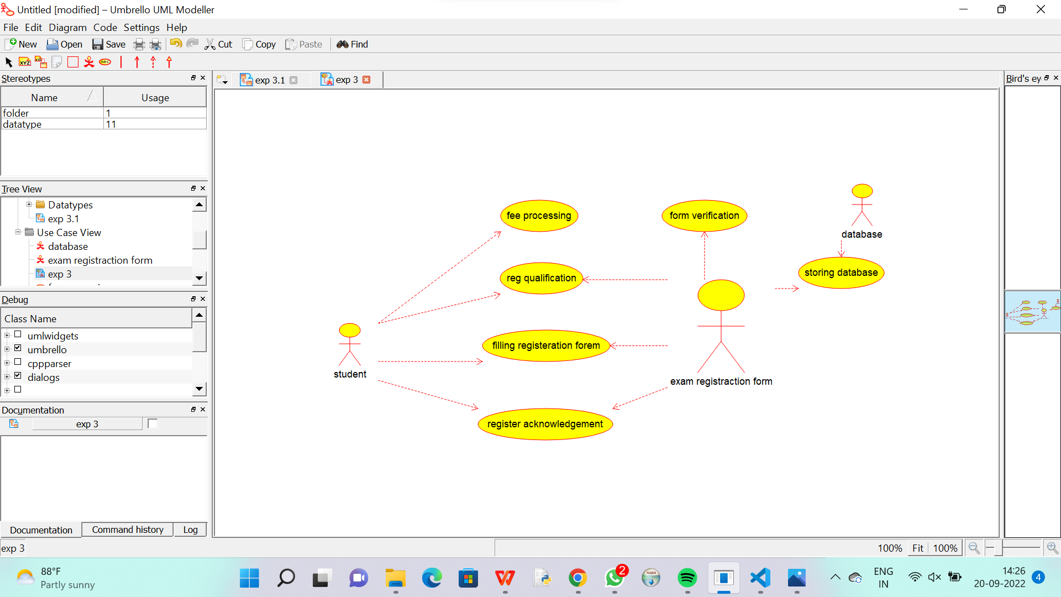

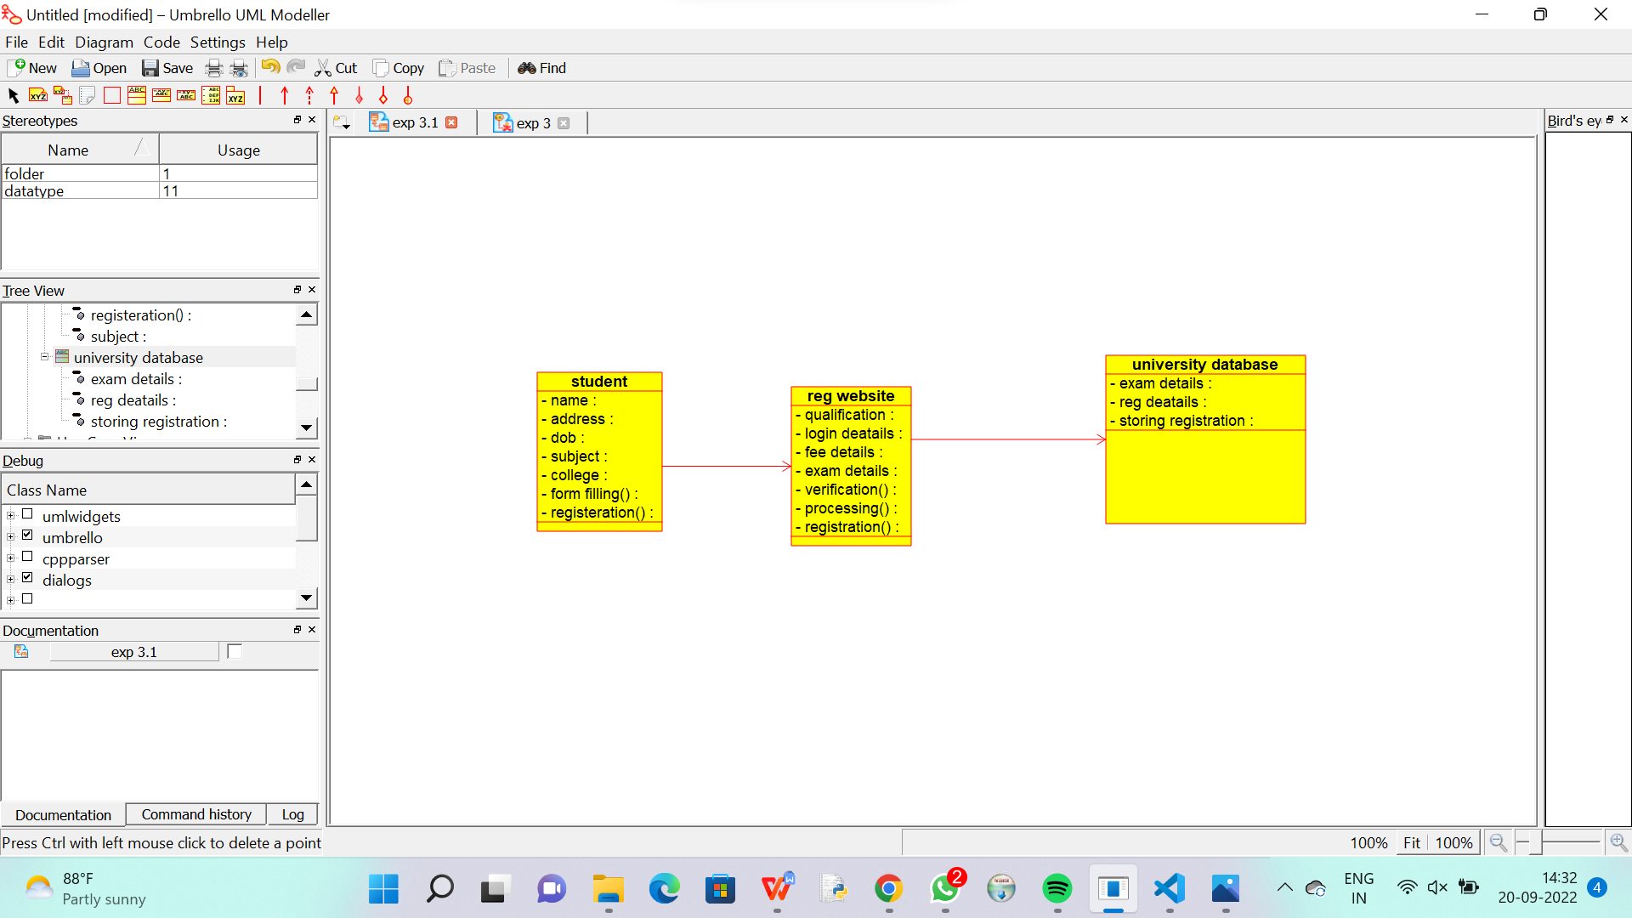

/**

 * Class reg_website

 */

public class reg_website {

  //

  // Fields

  //

  private void qualification;

  private void login_deatails;

  private void fee_details;

  private void exam_details;

  private void verification_;

  private void processing_;

  private void registration_;

  //

  // Constructors

  //

  public reg_website () { };

  //

  // Methods

  //

  //

  // Accessor methods

  //

  /**

   * Set the value of qualification

   * @param newVar the new value of qualification

   */

  private void setQualification (void newVar) {

    qualification = newVar;

  }

  /**

   * Get the value of qualification

   * @return the value of qualification

   */

  private void getQualification () {

    return qualification;

  }

  /**

   * Set the value of login_deatails

   * @param newVar the new value of login_deatails

   */

  private void setLogin_deatails (void newVar) {

    login_deatails = newVar;

  }

  /**

   * Get the value of login_deatails

   * @return the value of login_deatails

   */

  private void getLogin_deatails () {

    return login_deatails;

  }

  /**

   * Set the value of fee_details

   * @param newVar the new value of fee_details

   */

  private void setFee_details (void newVar) {

    fee_details = newVar;

  }

  /**

   * Get the value of fee_details

   * @return the value of fee_details

   */

  private void getFee_details () {

    return fee_details;

  }

  /**

   * Set the value of exam_details

   * @param newVar the new value of exam_details

   */

  private void setExam_details (void newVar) {

    exam_details = newVar;

  }

  /**

   * Get the value of exam_details

   * @return the value of exam_details

   */

  private void getExam_details () {

    return exam_details;

  }

  /**

   * Set the value of verification_

   * @param newVar the new value of verification_

   */

  private void setVerification_ (void newVar) {

    verification_ = newVar;

  }

  /**

   * Get the value of verification_

   * @return the value of verification_

   */

  private void getVerification_ () {

    return verification_;

  }

  /**

   * Set the value of processing_

   * @param newVar the new value of processing_

   */

  private void setProcessing_ (void newVar) {

    processing_ = newVar;

  }

  /**

   * Get the value of processing_

   * @return the value of processing_

   */

  private void getProcessing_ () {

    return processing_;

  }

  /**

   * Set the value of registration_

   * @param newVar the new value of registration_

   */

  private void setRegistration_ (void newVar) {

    registration_ = newVar;

  }

  /**

   * Get the value of registration_

   * @return the value of registration_

   */

  private void getRegistration_ () {

    return registration_;

  }

  //

  // Other methods

  //

}

/**

 * Class university_database

 */

public class university_database {

  //

  // Fields

  //

  private void exam_details;

  private void reg_deatails;

  private void storing_registration;

  //

  // Constructors

  //

  public university_database () { };

  //

  // Methods

  //

  //

  // Accessor methods

  //

  /**

   * Set the value of exam_details

   * @param newVar the new value of exam_details

   */

  private void setExam_details (void newVar) {

    exam_details = newVar;

  }

  /**

   * Get the value of exam_details

   * @return the value of exam_details

   */

  private void getExam_details () {

    return exam_details;

  }

  /**

   * Set the value of reg_deatails

   * @param newVar the new value of reg_deatails

   */

  private void setReg_deatails (void newVar) {

    reg_deatails = newVar;

  }

  /**

   * Get the value of reg_deatails

   * @return the value of reg_deatails

   */

  private void getReg_deatails () {

    return reg_deatails;

  }

  /**

   * Set the value of storing_registration

   * @param newVar the new value of storing_registration

   */

  private void setStoring_registration (void newVar) {

    storing_registration = newVar;

  }

  /**

   * Get the value of storing_registration

   * @return the value of storing_registration

   */

  private void getStoring_registration () {

    return storing_registration;

  }

  //

  // Other methods

  //

}